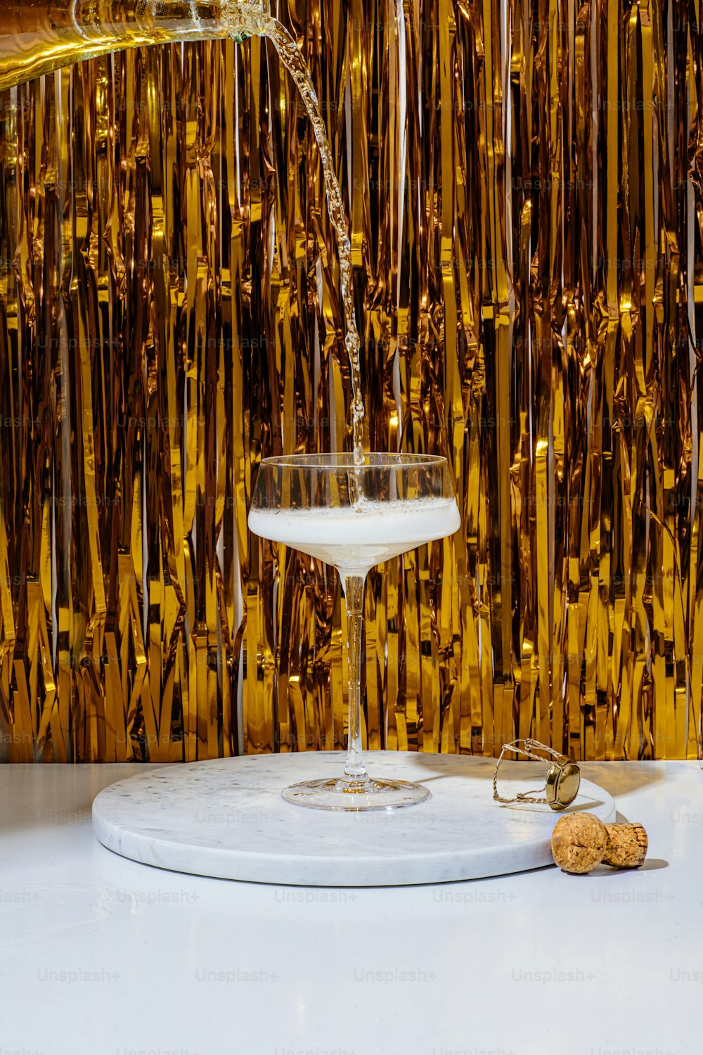

**Congratulations! Honor your recent graduate the Italian way.**

To make a reservation, please contact us.